## Project Design Phase-I

**Solution Architecture**

|  |  |
| --- | --- |
| Date | 13 November 2023 |
| Team ID | Team-592189 |
| Project Name | Lip Reading using Deep Learning |
| Maximum Marks | 4 Marks |

**Solution Architecture:**

Solution architecture is a complex process – with many sub-processes – that bridges the gap between business problems and technology solutions. Its goals are to:

* Deep learning-based lip reading systems have demonstrated promising results, achieving significant accuracy in controlled environments.
* Convolutional neural networks (CNNs) can extract features from lip images or videos, while recurrent neural networks (RNNs) can recognize words and phrases from these features.
* The software will have a modular architecture, with separate modules for lip image or video acquisition, pre-processing, feature extraction, sequence recognition, and output generation.
* The modules will communicate through well-defined interfaces, allowing for flexibility and extensibility.
* The software will utilize a hierarchical data structure to represent lip images or videos, enabling efficient feature extraction and sequence recognition.
* The software will acquire lip images or videos from a webcam or other source.
* It will pre-process the images or videos to normalize and enhance the visual information.
* The software will extract features from the pre-processed images or videos using deep learning models.
* It will recognize words and phrases from the extracted features using a recurrent neural network.
* The software will output the recognized speech as text in real time
* Integration with communication tools and assistive technologies
* User-friendly interface for configuration and customization

**Example - Solution Architecture Diagram:**

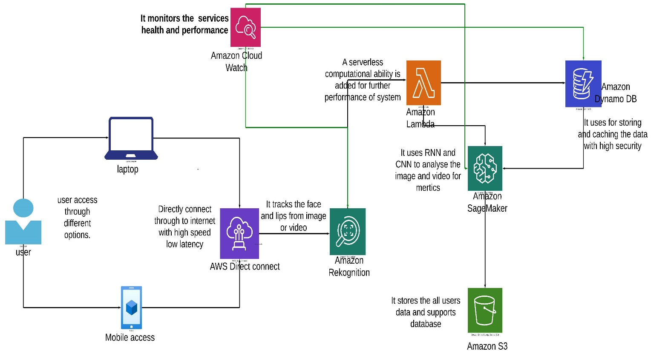

*Figure 1: Architecture and data flow of the Lip Reading using Deep Learning.*

**Reference:** [**https://lucid.app/lucidchart/557064b2-ffa8-4340-8dd6-aa2b63cb7e6b/edit?viewport_loc=-2748%2C-2389%2C9720%2C4321%2C0_0&invitationId=inv_404816a1-31d8-4630-855e-b08d5b11baf6**](https://lucid.app/lucidchart/557064b2-ffa8-4340-8dd6-aa2b63cb7e6b/edit?viewport_loc=-2748%2C-2389%2C9720%2C4321%2C0_0&invitationId=inv_404816a1-31d8-4630-855e-b08d5b11baf6)